The derivation for the parabolic intersect solve is as follows:

The system to solve is set up in this way:

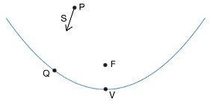

P is the ray start point while S is the ray direction. Q is the supposed intersect point. F and V are the focus and vertex of the parabola. It is assumed that all of these points and vectors are given except for Q.

We don’t solve for Q directly, rather we solve for the distance it takes the ray defined by P and S to reach Q.

The equation that defines the parabola is the following:



and we substitute the following in for Q:



where c is a single value that multiplies the vector S.

The value c is the only unknown at this point, so we go ahead and solve for it. This turns into a quadratic equation for c, which is solved using the quadratic formula.

In the Matlab code, the values A, B, and C are calculated, which are the coefficients of the homogeneous quadratic equation for c (which is Ac2+Bc+C=0). These are then used in the quadratic equation to solve for c. Values for c are turned into intersect points Q using Q=P+cS.

The code takes into account that sometimes the A coefficient can become small and make the calculation of c run into precision errors. The code is set up so that if A<1e-8, then c is approximated simply with –C/B, which is the solution to the linear equation when A is set to 0.

Approximating c to some degree is ok. The code ends with a numerical calculation that brings approximate solutions into tolerable limits.